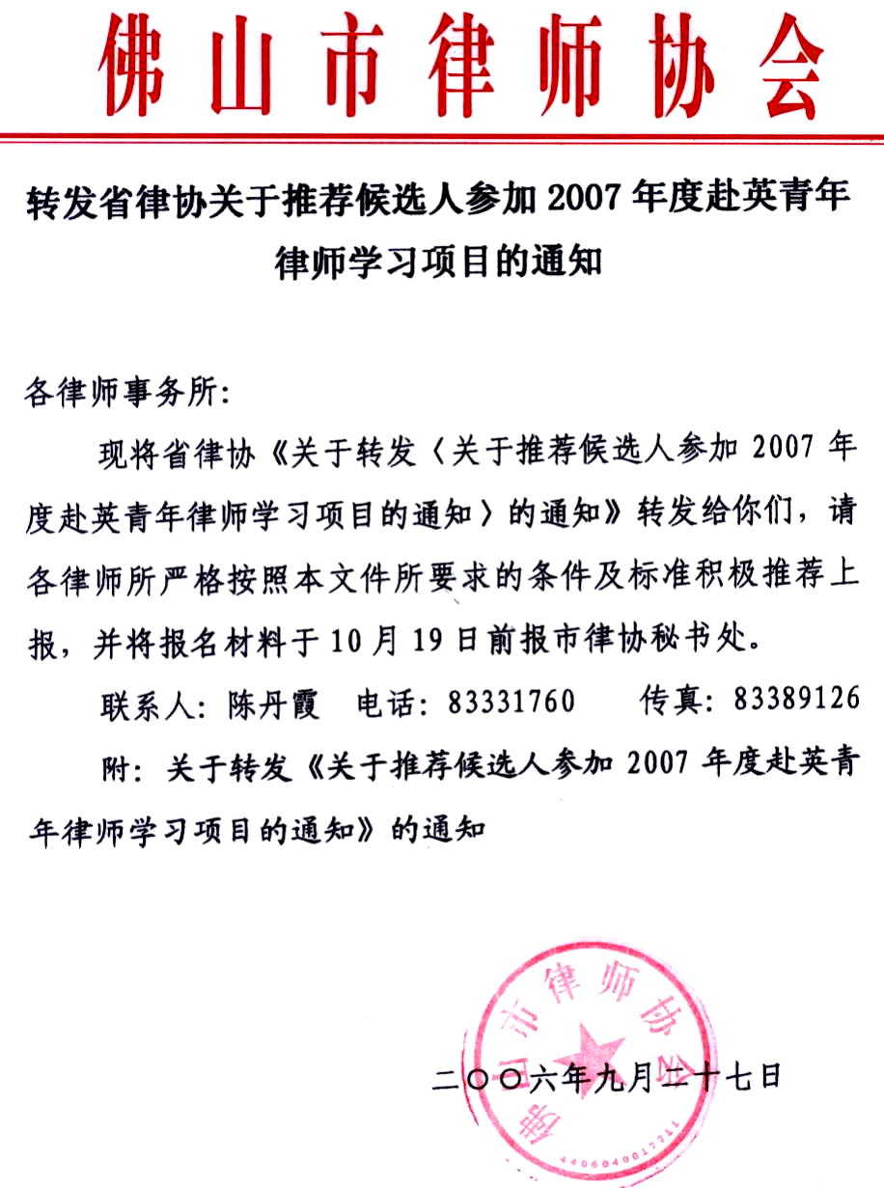
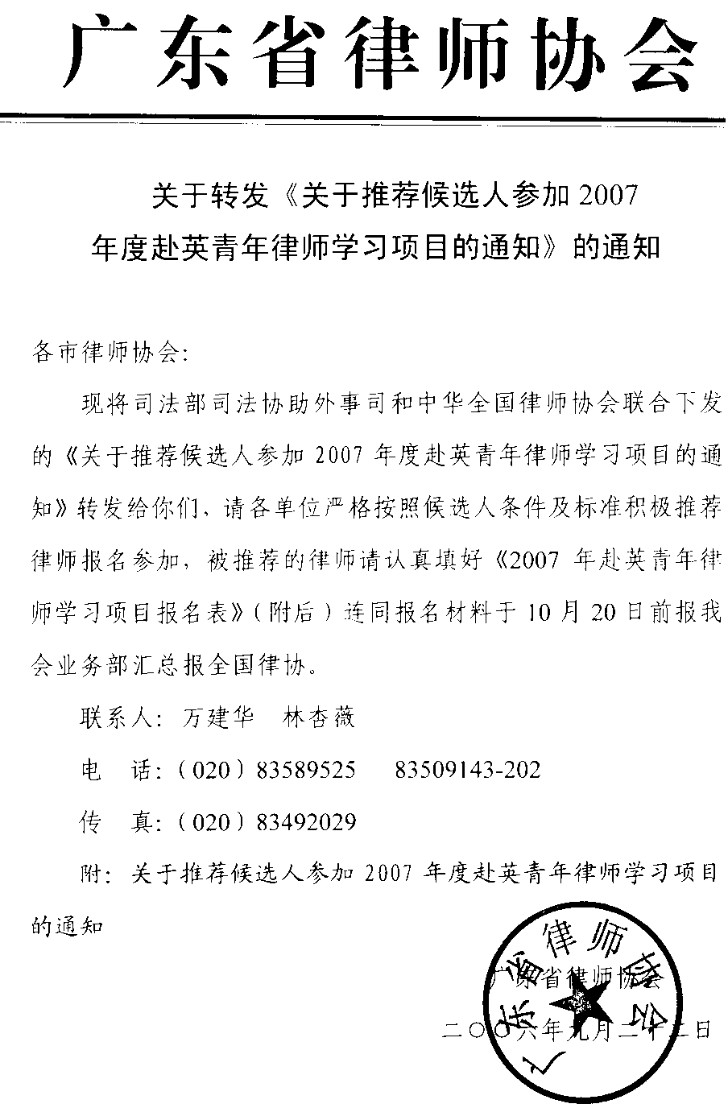

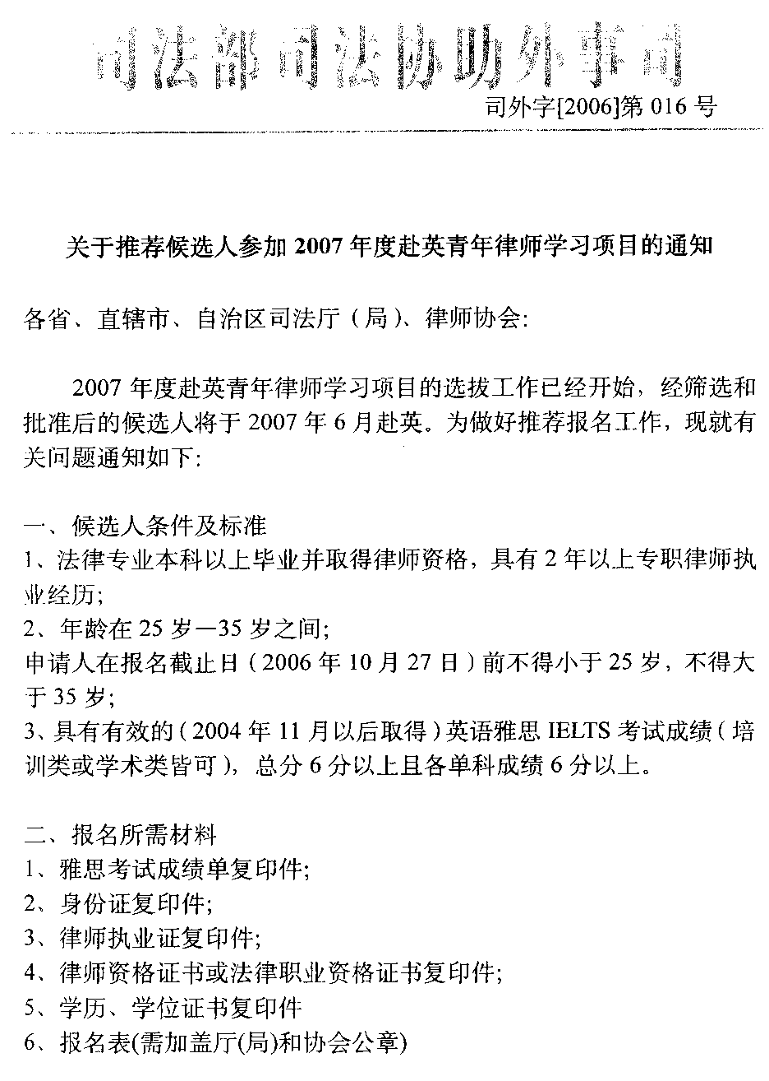
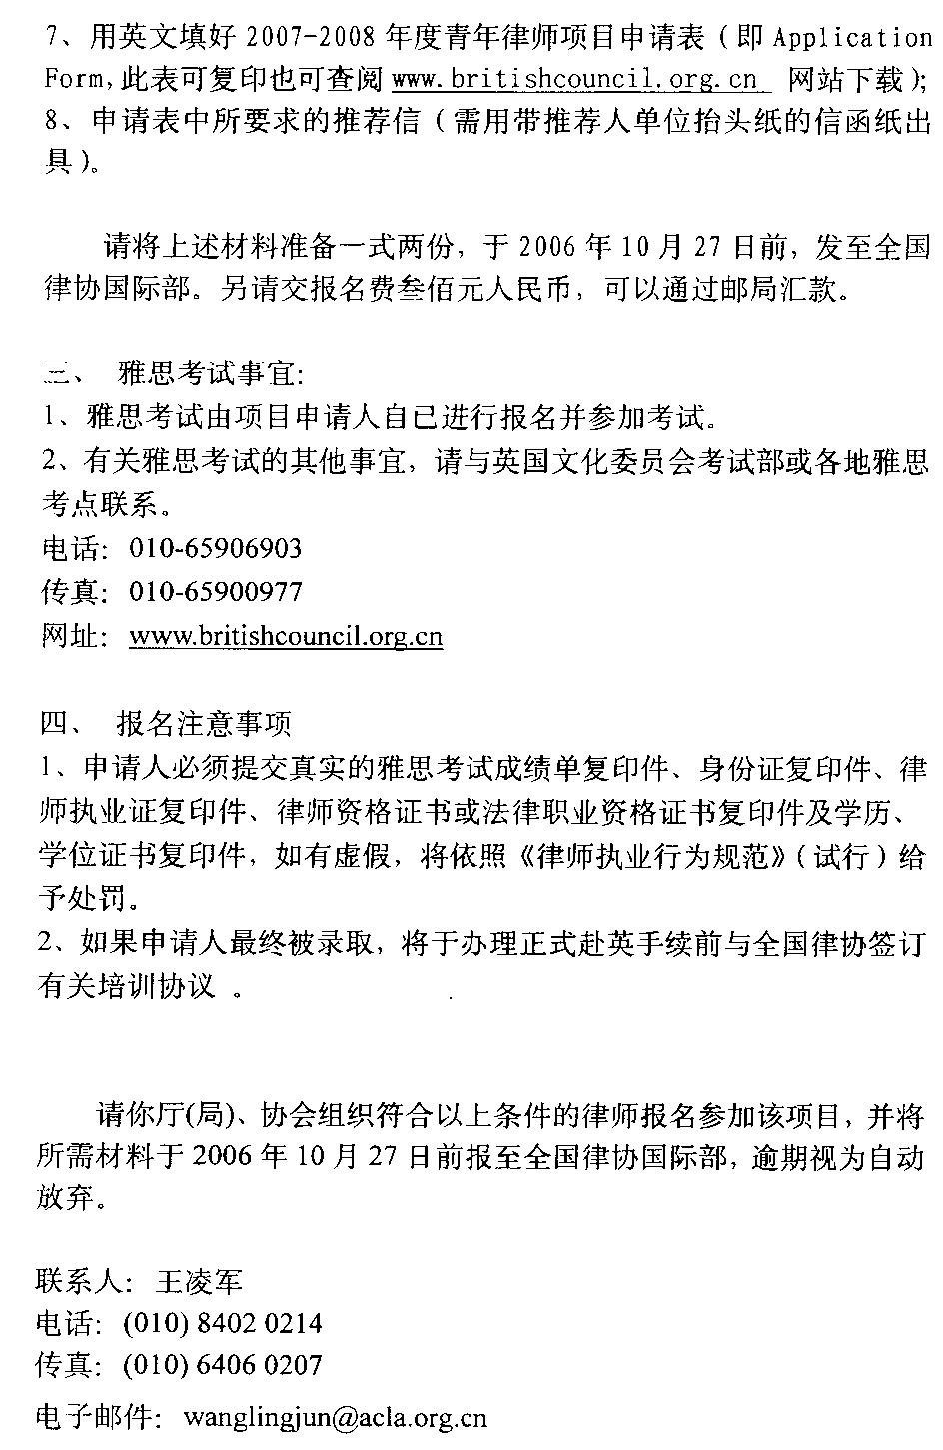
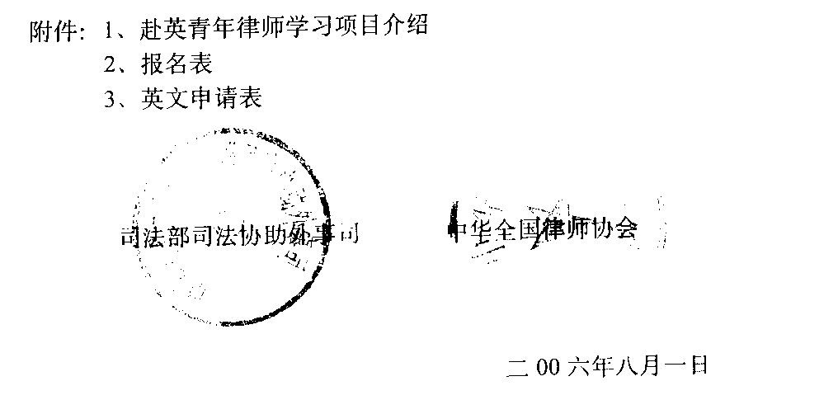
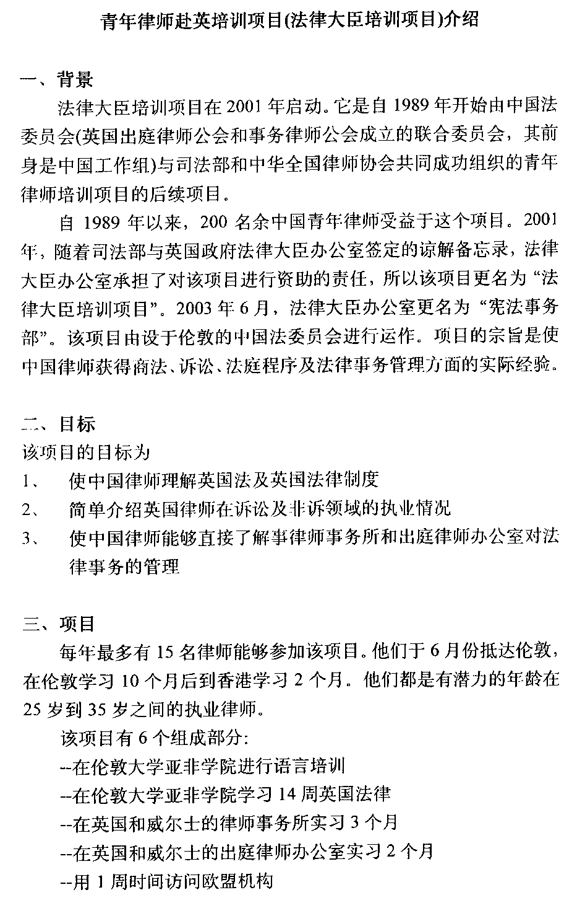
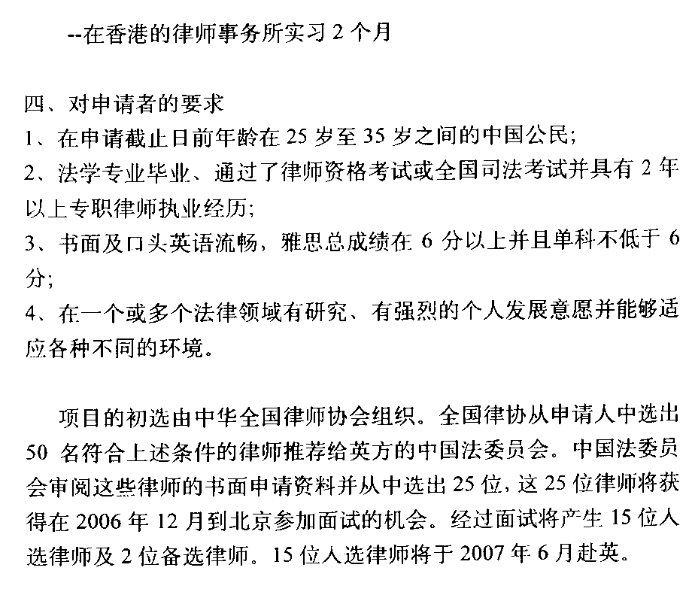
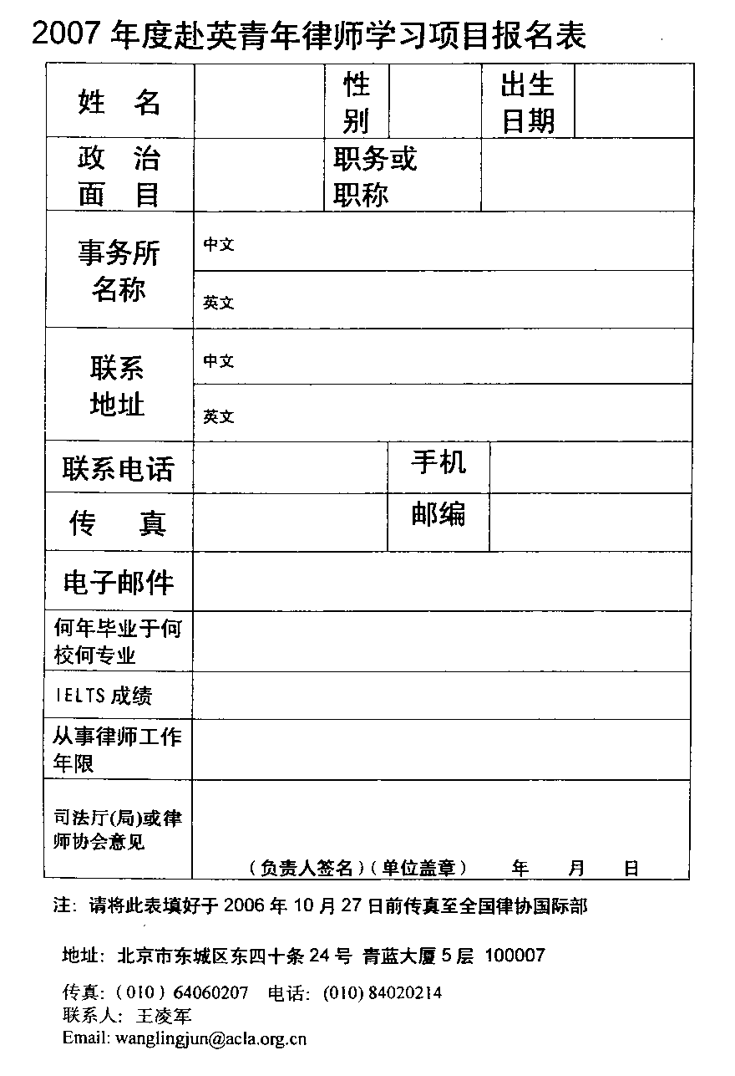
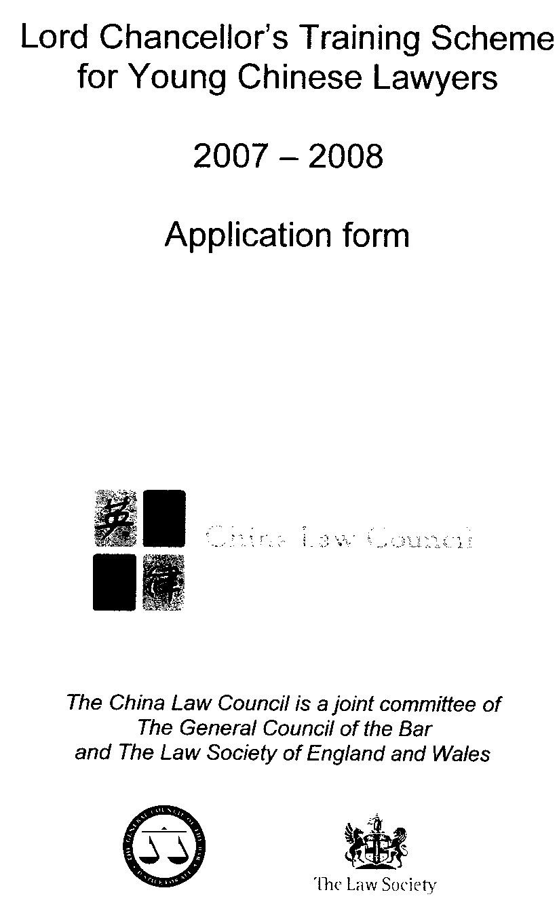
Please complete all parts on this form in

Photo
black ink or typescript and attach a
recent photograph of yourself in the
space opposite.

Incomplete forms will not be accepted.
Please return completed form to the All China Lawyers’ Association.

Part A: Personal details

Family Name: First Name:

(as on passport)

Mr Mrs Miss Ms Male Female
Title: Sex:

Place of birth: Date of birth:

(town and province)

Single Married
Status: ID card number:

Will any member of your family accompany you to the UK? If so, please specify which ones and state
how you propose to meet their expenses. Under the Lord Chancellor’s Training Scheme we cannot pay
married or child allowances: any stipend you receive is intended to cover your expenses only.

Address for correspondence in China in Chinese: Name, address and telephone number of next
of kin or person in China who should be contacted
in the event of an emergency:

Telephone number:
(please state relationship)

Telephone number:

Where are you currently working? Please state your employer’s name and address:

What is your job title?

If you are currently studying, what qualification do you expect to obtain, and when do you expect to obtain it?

Have you ever studied in the UK? If yes, did you receive a British government funded award or
Scholarship?

Yes No Yes No

If you have studied before in the UK, please give details:

Have you ever visited the UK on holiday or for business? If yes, please indicate when and what the purpose of the visit was:

Part B: Academic Background

Please list academic qualifications obtained since completing your secondary education, stating the institutions
attended, the main subjects of your study and when the main courses started and finished. Please indicate with an
asterisk (*) those courses which were entirely or mainly conducted in English – i.e. where the language of instruction or supervision was English:

Qualification  (including class or level) | Institution | Subject | From | To
Part C: Professional Background /Career History

Please list all positions held since completing your secondary or further education:

Position | Organisation/Institution | From | To

Part D: Current Duties

Please provide brief details of your current job and legal specialisation(s):

Which areas of law would you hope to cover while on placement at solicitors’ firms/barristers’ chambers as part of the Scheme (list five in order of priority):
1. 2.

3. 4.

5.

When was your firm founded? How many partners does it have, and how many of the staff (apart from the partners) are qualified lawyers?

Please provide a brief description of the core work of your firm:

How much contact do you have with clients? What is the nature of the contact e.g. taking instructions, advising?

Are the majority of your clients - Private individuals or corporates?

How much contact do you have with foreign clients?

What responsibilities (if any) do you have for managing, supervising or training other members of staff?

Who monitors your work?

What role do you play in the overall management of your firm?

Part E: Statement of Proposed Training

In not more than 500 words, please state why you wish to participate in the Scheme and explain how you think you will benefit in terms of career and personal development once you have returned to China. Please say how your training will benefit your organisation and China’s legal development:

Describe an ethical dilemma you have experienced firsthand. Discuss how you thought about and managed
the situation:

Briefly describe a recent case (contentious or non-contentious) that you have been working on:

Part F: Other details

English Language Skills

How often do you use English? Regularly, occasionally, or never

- To read documents:

- To draft contracts/legal documents:

- In written correspondence with clients/

third parties:

- On the telephone/in meetings with

clients/third parties:

Other activities

Give details of your hobbies, sporting activities and other outside interests, for example any work in the community:

Declaration of Health

Note: Any illness declared below will not necessarily debar you from receiving an award, but the information supplied will enable the China Law Council to ensure the training is arranged at a suitable time. Pregnancy or recent birth is not a bar to any award but you have the option to postpone an award if you wish. If an award is made, you will be required to have a medical examination and chest X-ray. You will be informed about this later on.

Your full name:

Date of Birth:

1. I declare that I am in good health and fit to take up an award in Britain.

2. I am not pregnant I am pregnant

3. I am not receiving medical treatment I am receiving medical treatment at present

If you are receiving medical treatment, please give details:

In the past twelve months I have In the past twelve months I have received
4. not received any medical treatment medical treatment

If you have received medical treatment in the past twelve months, please give details:

Signed Date

Part G: Authorisation

This part must be completed by both applicant and his/her employer.

- Candidate
In English in Chinese

Name:

Position:

Department:

Organisation:

Address and postcode:

Telephone No (office):

Telephone No. (home):

Fax:

Email:

Mobile phone:

I confirm that the information on this application form is true and complete. I undertake to inform the All China Lawyers’ Association of any changes to the information contained herein which may arise prior to the end of the selection process and understand that failure to do so could result in my disqualification from the programme.

Signed Date

- Employer
In English in Chinese

Name of responsible person:

Position:

Department:

Organisation:

Address and postcode:

Telephone No (office):

Telephone No. (home):

Fax:

Email:

Mobile phone:

I confirm that the candidate named in 1. above is formally nominated as a candidate for the Lord Chancellor’s Training Scheme for Young Chinese Lawyers 2006-2007. He/she will be allowed to accept the scholarship if selected.

Signed Date

Stamp of organisation:

Part H: Referee

Please provide details of one referee below. The referee should be your current employer or a previous employer or academic. This referee should complete a confidential letter of reference, to be submitted with this application form. The reference should be completed in Chinese.

REFEREE

Title and name:

Position:

Address:

How long have you known this referee?

What is his/her professional relationship to you?

